**Model Development Phase Template**

|  |  |
| --- | --- |
| Date | 24 June 2025 |
| Team ID | SWTID1750316859 |
| Project Title | ASL - Alphabet Image Recognition |
| Maximum Marks | 10 Marks |

**Initial Model Training Code, Model Validation and Evaluation Report**

The initial model training code will be showcased in the future through a screenshot. The model validation and evaluation report will include a summary and training and validation performance metrics for multiple models, presented through respective screenshots.

**Initial Model Training Code (5 marks):**

**MobileNet-V2:**

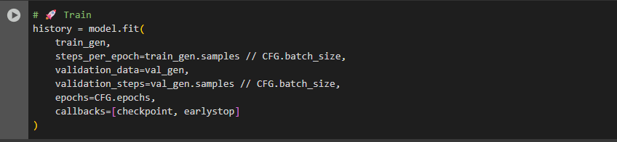

VGG16:  
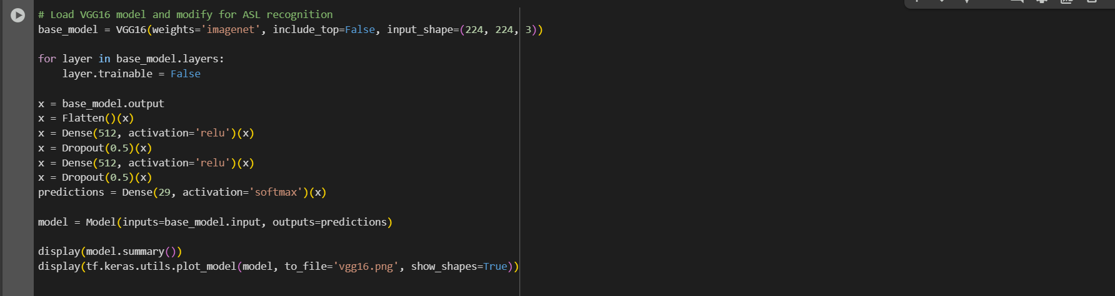

**Model Validation and Evaluation Report (5 marks):**

|  |  |  |
| --- | --- | --- |
| **Model** | **Summary** | **Training and Validation Performance Metrics** |
| MobileNetV2 |  |  |
| VGG16 |  | AS PER EPOCH TIME IS 4 HOURS AND ACCURACY IS NEGLIGIBLY LOW AFTER WAITING FOR 3 EPOCHS WE DECIDED TO DISCONTINUE THIS MODEL AND FINALIZE MOBILENET-V2. |